**Project Proposal: Analyzing and Predicting Vehicle Accidents in Arizona Using Machine Learning**

**Group 1:** Safe Streets Squad

Ritika, Tiffany, Walter, Kenway

**Project Overview**

The goal of this project is to analyze traffic accident data in the Metro Phoenix area to identify high-risk intersections and potential causes of accidents. We will use machine learning to predict future accidents and create visualizations to compare the accident rates and severity in different cities. The final deliverables will include an interactive map, comparative analysis, and comprehensive documentation.

**Key Questions**

1. What are the most accident-prone intersections/areas in the Metro Phoenix area?

2. Which city has the highest volume of accidents?

3. **Which city has the worst accidents in terms of severity (impact of traffic)?**

4. Does weather conduction impact the volume of accidents? (Monsoon season June-Sept?)

Tableau Map ([Link](https://public.tableau.com/app/profile/kenway.tennant1864/viz/Traffic_Map/Sheet1?publish=yes))

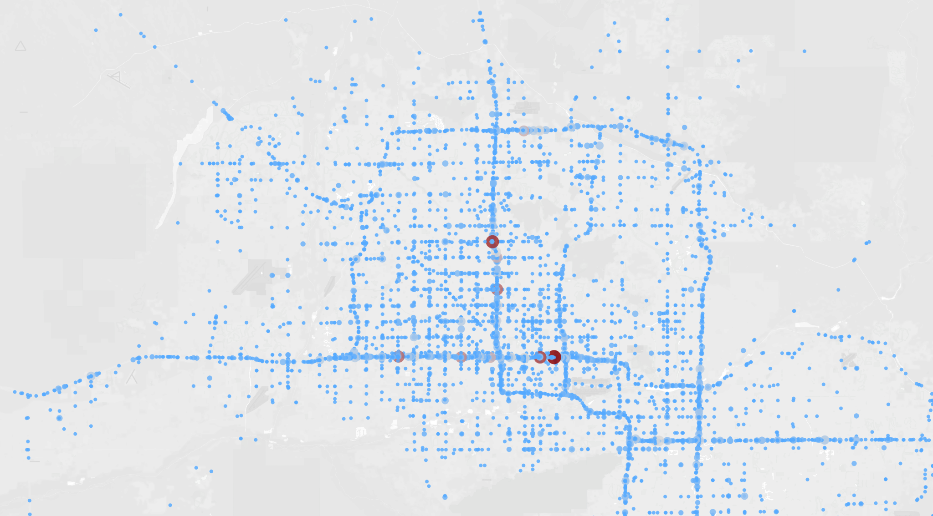

Zipcode Comparison (bar chart count for each zip) (In az_visualuzations.ipynb)

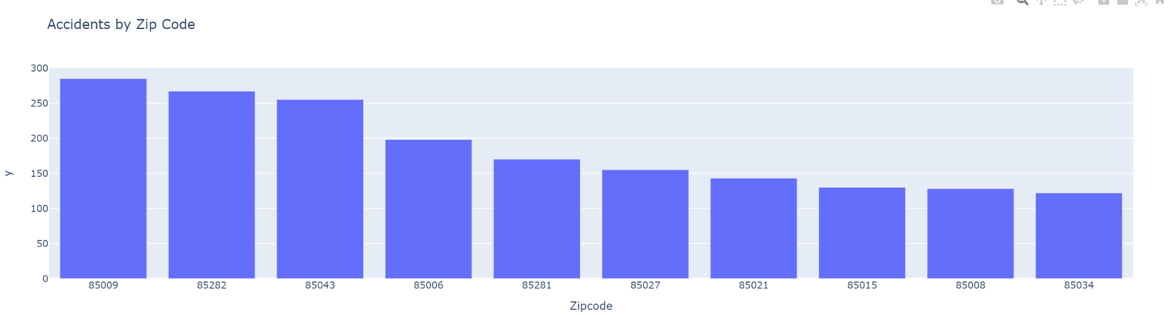

County (num count for each county, compare to population) (In az_visualuzations.ipynb)

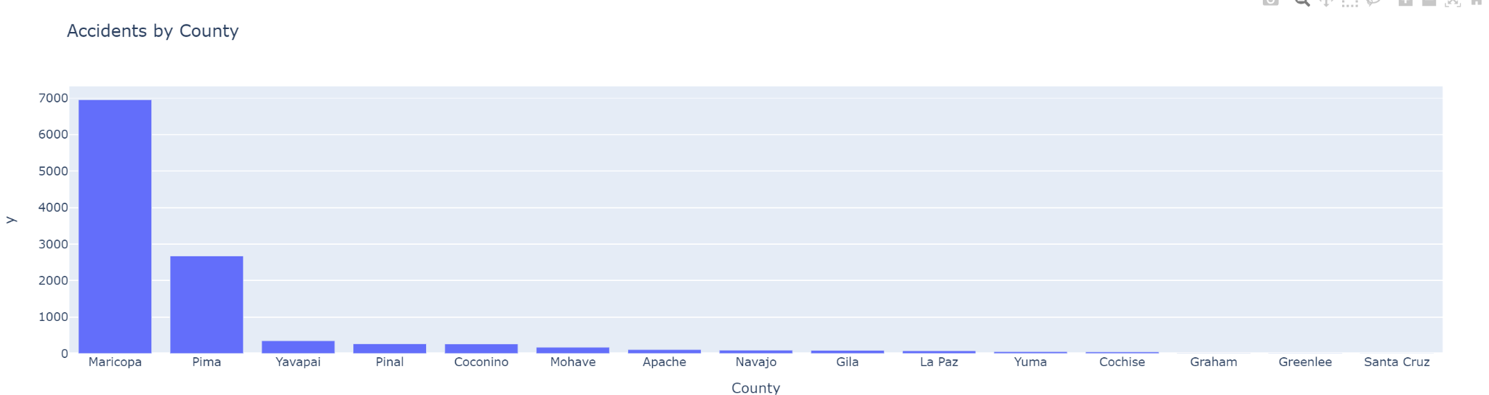

Weather condition count (In az_visualuzations.ipynb)

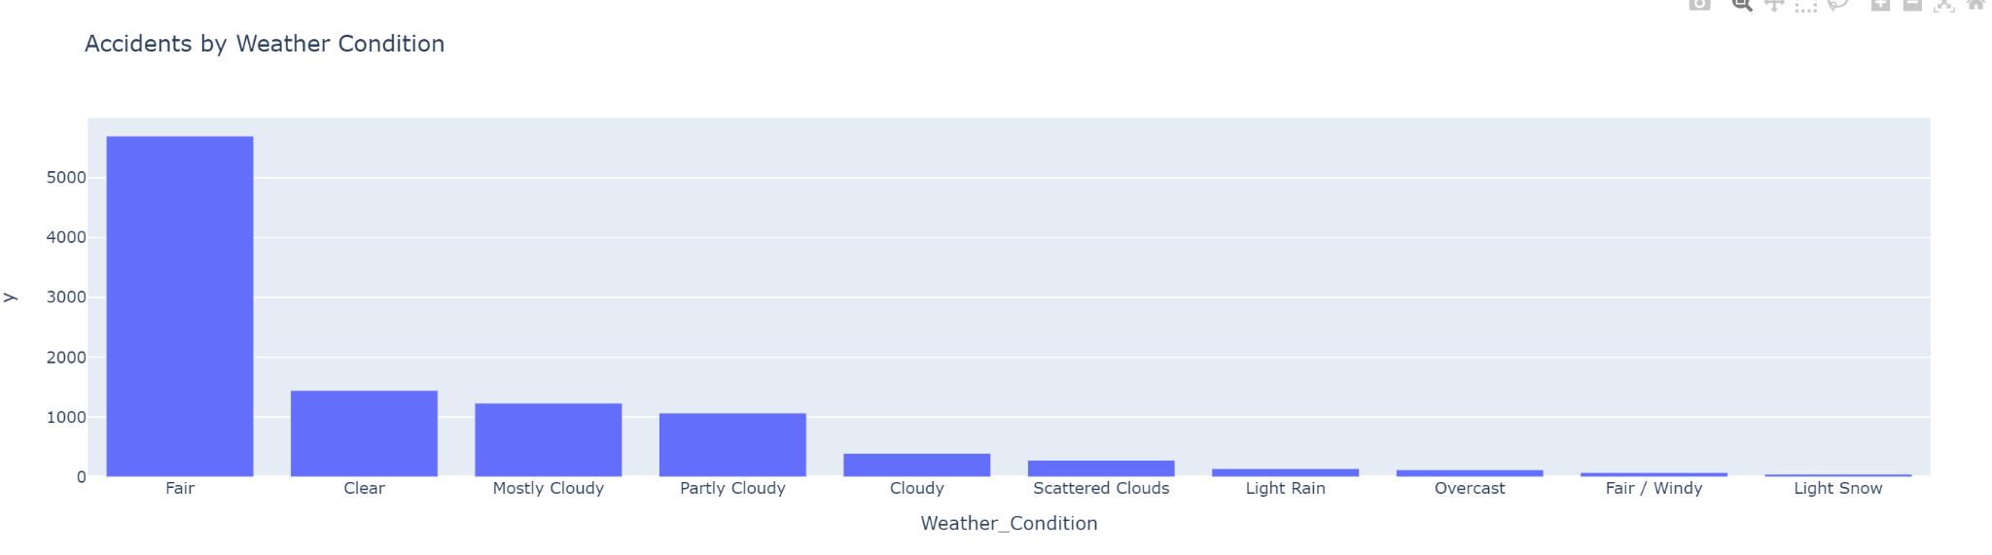

July and August (Monsoon season) (In az_visualuzations.ipynb)

*Note: This is a count for the monsoon season over 4 years, still shows that most accidents occur in clear weather*

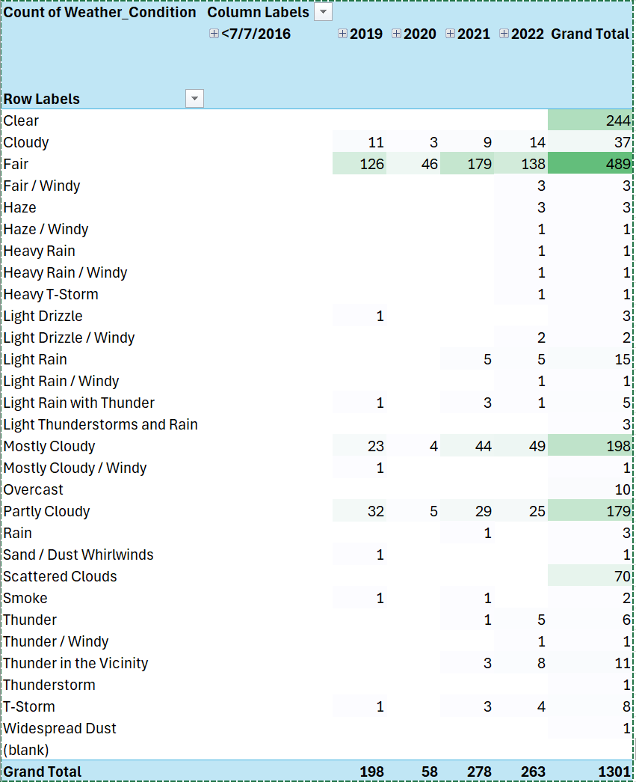

**Project Timeline and Responsibilities**

**Phase 1: Ideation and Planning**

· Project Ideation

· Proposal and Gantt Chart

**Phase 2: Data Handling**

· Data Fetching/API Integration

· Data Cleaning

· Data Analysis

**Phase 3: Development**

· Database Setup

· Visualizations

* Tableau Map
* Zipcode Comparison (bar chart count for each zip)
* County (num count for each county, compared to population)
* Weather condition count
* July and August (Monsoon season)

· Building the Machine Learning Model

· Testing the Model

**Phase 4: Documentation and Presentation**

· Creating Documentation

· Creating the Presentation

**Deliverables**

1. Comparative Analysis:

· Top 5 cities with the highest accident rates by volume (visualized using Matplotlib)

· Top 5 cities with the highest accident severity rates (visualized using Matplotlib)

2. Interactive Map:

· Display accident-prone areas using Tableau

3. Documentation:

· Comprehensive documentation covering data sources, analysis methods, model details, and user guide for the visualizations

4. Presentation:

· A detailed presentation summarizing findings, methods, and future work

**Tools and Technologies**

· Database: PostgreSQL or SQLite (due to large file size, csv cannot be added to GitHub)

· Data Visualization: Matplotlib for comparative analysis, Tableau for interactive mapping

· Programming Languages: Python for data analysis, machine learning, and visualization

· Machine Learning: Algorithms and techniques for predicting future accidents

**Conclusion**

This project aims to provide valuable insights into traffic safety in the Metro Phoenix area by leveraging machine learning and data visualization techniques. The findings will help in identifying high-risk areas and potential causes of accidents, which can be crucial for city planners and policymakers to improve road safety.